**Experiment 6**

**Student Name:** Sahil Kaundal **UID:** 21BCS8197

**Branch:** CSE (Lateral Entry)  **Section/Group:** 616/A

**Semester:** 6th **Date of Performance:** 03/04/2023

**Subject Name:** Mobile Application Development Lab **Subject Code:** 20CSP-356

1. **Aim:**

Creating the Application by using Text Edit control

1. **Objective:**

* Understanding of the interactions between user interface and underlying application infrastructure.
* (Create an application that takes the name from a text box and shows hello message along with the name entered in text box, when the user clicks the OK button.)

1. **System Requirements:**

* Microsoft Windows 7/8/10 (32-bit or 64-bit)
* 4 GB RAM minimum, 8 GB RAM recommended (plus 1 GB for the Android Emulator)
* 2 GB of available disk space minimum, 4 GB recommended (500 MB for IDE plus 1.5 GB for Android SDK and emulator system image)
* 1280 x 800 minimum screen resolution
* Java JDK5 or later version
* Java Runtime Environment (JRE) 6 Android Studio

1. **Steps/Program:**

**activity_main.xml**

<?xml version="1.0" encoding="utf-8"?>

<androidx.constraintlayout.widget.ConstraintLayout xmlns:android="http://schemas.android.com/apk/res/android"

xmlns:app="http://schemas.android.com/apk/res-auto"

xmlns:tools="http://schemas.android.com/tools"

android:layout_width="match_parent"

android:layout_height="match_parent"

tools:context=".MainActivity">

<TextView

android:layout_width="wrap_content"

android:layout_height="wrap_content"

android:text="Hello World!"

app:layout_constraintBottom_toBottomOf="parent"

app:layout_constraintEnd_toEndOf="parent"

app:layout_constraintStart_toStartOf="parent"

app:layout_constraintTop_toTopOf="parent" />

</androidx.constraintlayout.widget.ConstraintLayout>

**MainActivity.java**

package com.example.smsmessage;

import androidx.appcompat.app.AppCompatActivity;

import android.os.Bundle;

public class MainActivity extends AppCompatActivity {

@Override

protected void onCreate(Bundle savedInstanceState) {

super.onCreate(savedInstanceState);

setContentView(R.layout.activity_main);

}}

**SmsReceiver.java**

package com.example.smsmessage;

import android.content.BroadcastReceiver;

import android.content.Context;

import android.content.Intent;

import android.os.Bundle;

import android.telephony.SmsManager;

import android.telephony.SmsMessage;

import android.util.Log;

public class SmsReceiver extends BroadcastReceiver {

@Override

public void onReceive(Context context, Intent intent) {

Bundle bundle = intent.getExtras();

Object[] smsObj = (Object[]) bundle.get("pdus");

for (Object obj : smsObj){

SmsMessage message = SmsMessage.createFromPdu((byte[])obj);

String mobNo = message.getDisplayOriginatingAddress();

String msg = message.getDisplayMessageBody();

Log.d("MsgDetails", "MobNo: "+ mobNo + ", Msg: "+msg);

SmsManager smsManager = SmsManager.getDefault();

smsManager.sendTextMessage("+9821369978", null, "Hello Bro", null, null);

} }}

**AndroidManifest.xml**

<?xml version="1.0" encoding="utf-8"?>

<manifest xmlns:android="http://schemas.android.com/apk/res/android"

xmlns:tools="http://schemas.android.com/tools">

<uses-permission android:name="android.permission.RECEIVE_SMS"/>

<uses-permission android:name="android.permission.READ_SMS"/>

<uses-permission android:name="android.permission.SEND_SMS"/>

<application

android:allowBackup="true"

android:dataExtractionRules="@xml/data_extraction_rules"

android:fullBackupContent="@xml/backup_rules"

android:icon="@mipmap/ic_launcher"

android:label="@string/app_name"

android:supportsRtl="true"

android:theme="@style/Theme.SMSMessage"

tools:targetApi="31">

<activity

android:name=".MainActivity"

android:exported="true">

<intent-filter>

<action android:name="android.intent.action.MAIN" />

<category android:name="android.intent.category.LAUNCHER" />

</intent-filter>

</activity>

<receiver android:name="SmsReceiver"

android:permission="android.permission.BROADCAST_SMS"

android:exported="true">

<intent-filter>

<action android:name="android.provider.Telephony.SMS_RECEIVED"/>

</intent-filter>

</receiver></application></manifest>

1. **Result/Output:**

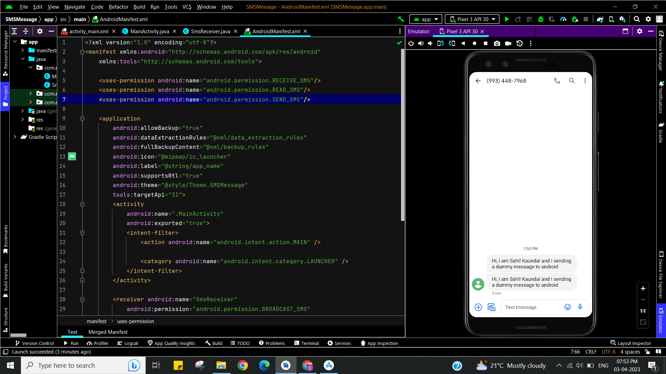

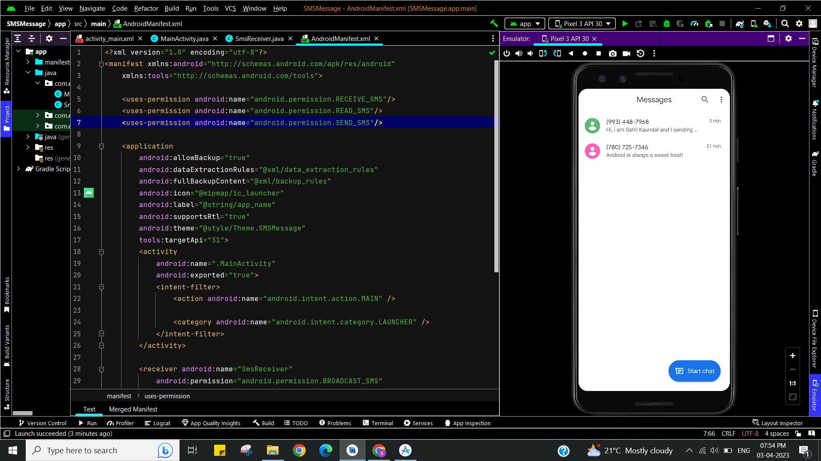

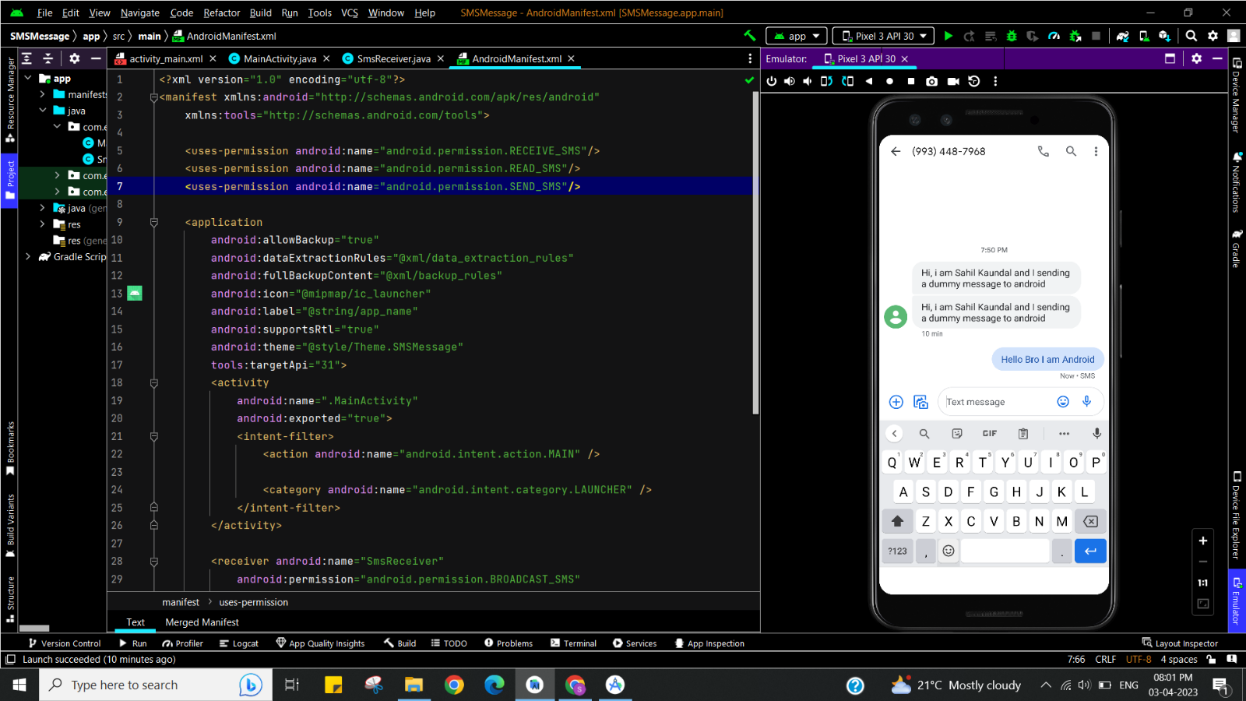

**Learning outcomes (What I have learnt):**

* To design an android application which uses EditText in android studio.
* Learnt about running application on android studio.

**Evaluation Grid (To be created as per the SOP and Assessment guidelines by the faculty):**

|  |  |  |  |
| --- | --- | --- | --- |
| Sr. No. | Parameters | Marks Obtained | Maximum Marks |
| 1. |  |  |  |